

Project Report on

# TRAVEL AND TOURIST MANAGEMENT SYSTEM

# Submitted by:

|  |  |  |  |  |
| --- | --- | --- | --- | --- |
| **Name** | **Section** | **Reg. No** | **Roll No.** | **Group** |
| Aripelly Akshay Kumar | K21QT | 12115139 | 49 | 2 |
| Masana SwarajDeep | K21QT | 12113998 | 64 | 2 |
| Dongala Praveen | K21QT | 12115126 | 29 | 2 |

**Submitted to:** Dr.Bhimasen Moharana

# ABSTRACT

The travel and tourist management system is a software solution designed to streamline the process of managing travel bookings and itinerary for tourists. The system facilitates efficient handling of travel arrangements, including flights, accommodations, transportation, and activities, by automating the booking process and providing real-time updates. The system enables travel agencies and tour operators to create custom travel packages, manage reservations, and track payments. It also provides a user-friendly interface for travelers to access and manage their itineraries, view trip details, and communicate with travel agents. Overall, the travel and tourist management system enhances the customer experience and improves the efficiency of travel management processes for businesses.

# INTRODUCTION

The demand for travel and tourism services is rising quickly, making the tourism industry one of the industries with the fastest growth rates worldwide. The requirement for effective management systems to handle the rising volume of travel bookings and arrangements develops as the business expands. A software programme called the travel and tourist management system was created to help travellers, tour guides, and travel firms manage their travel plans.

The booking of flights, lodging, transportation, and activities is automated by the travel and tourist management system, which also offers real-time updates on modifications to plans. By offering a user-friendly interface for both travel agents and customers, this system streamlines the trip management process, lessening the strain for travel agencies and enhancing the customer experience.

The travel and tourist management system is a software solution designed to streamline the process of managing travel bookings and itinerary for tourists. The system facilitates efficient handling of travel arrangements, including flights, accommodations, transportation, and activities, by automating the booking process and providing real-time updates. The system enables travel agencies and tour operators to create custom travel packages, manage reservations, and track payments. It also provides a user-friendly interface for travelers to access and manage their itineraries, view trip details, and communicate with travel agents. Overall, the travel and tourist management system enhances the customer experience and improves the efficiency of travel management processes for businesses.

**Software Requirements**

1.Java Development Kit (JDK) - This includes the Java Runtime Environment (JRE) and the Java compiler that will allow you to write and run Java programs.

2.Integrated Development Environment (IDE) - You can use an IDE such as Eclipse, NetBeans, or IntelliJ IDEA to write, test, and debug your code.

3.JavaFX - A Java library that provides a set of graphics and user interface components to create graphical user interfaces (GUIs) for Java applications.

4.You need to have basic knowledge of Java, object-oriented programming, and either JavaFX or Swing for the graphical interface12

**Hardware Requirements**

1.Computer with sufficient memory and processing power to run the software.

2.A monitor with a resolution of at least 1024 x 768 pixels to display the game graphics.

Note that the specific hardware and software requirements may vary depending on the complexity of your game and the specific tools and libraries you choose to use.

**Functional requirements**

Requirements that describe what the system should do:

1.The program can allow users to login or register

2.The program should store the data of the users in the data base

3.The user should be able to register and book the tour according to his choice provided

4.The register should be able to choose if he needs a guide, residence etc..

**Non-functional requirements**

Requirements that describe how well the system should do what it does:

1.The program should be responsive and smooth, with no lag or delay in the user's actions.

2.The interface should be easy to understand and book, with clear instructions and intuitive controls.

3.The interface should have a visually appealing design with attractive graphics.

4.The program should be compatible with different operating systems and devices.

5.The program should be secure and free from any vulnerabilities or malicious code.

**ER-Diagram**

An Entity Relationship Diagram (ERD) is a visual representation of different entities within a system and how they relate to each other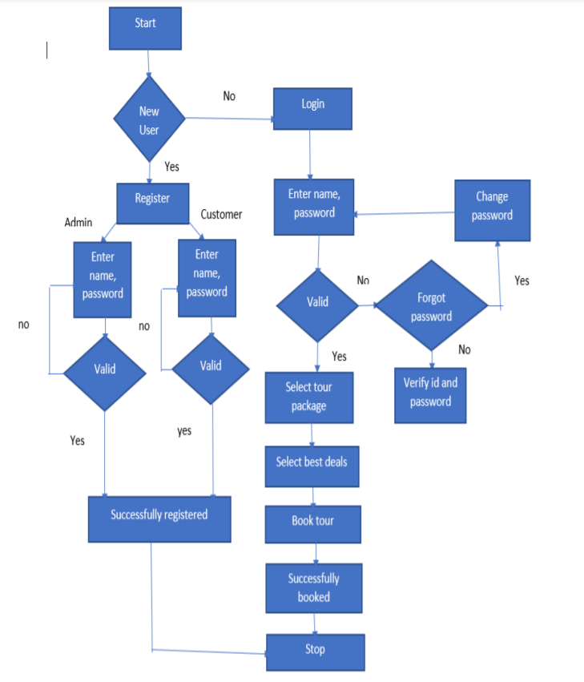. In our project-ER diagram, it explains when the user opens the site the login page appears asking if he is a new user or an existing one if he is already a user then he/she should enter the login details and enter the page or if he is a new user then they should register for it. after further steps, the user should select the tour package, select the best deals for it, and just need to book for the same.

# Data Flow Diagram( DFD)

# A Data Flow Diagram (DFD) is a graphical representation of the flow of data through an information system.

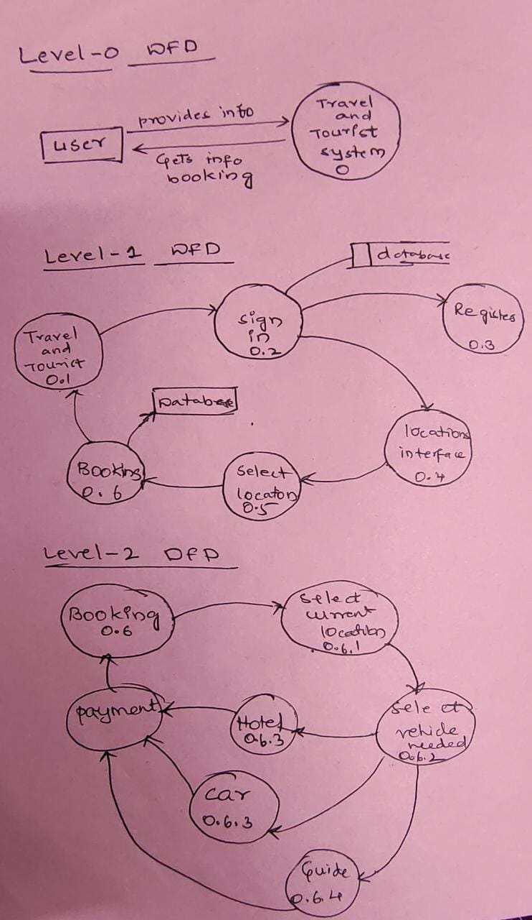

# User Interfaces:

# 

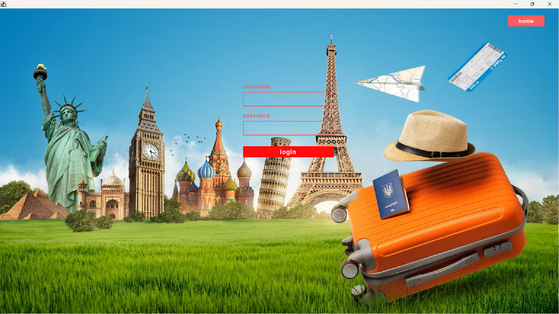

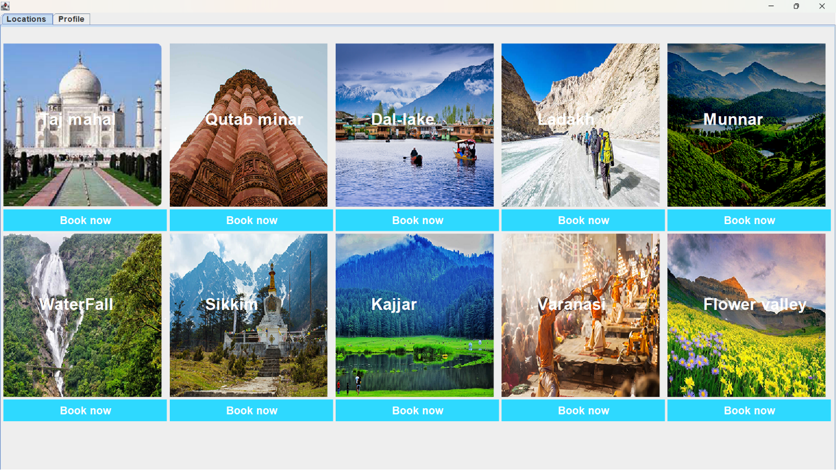

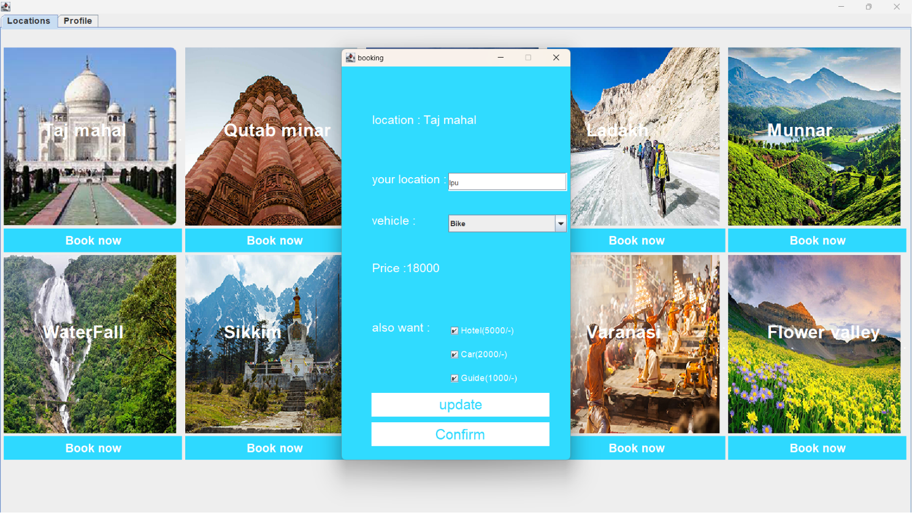

**SOURCE CODE OF THE PROJECT**

[**https://ufile.io/m7xep0is**](https://ufile.io/m7xep0is)

**or**

[**https://github.com/I-Kaizoku/Travel-and-Tourist-management-system.git**](https://github.com/I-Kaizoku/Travel-and-Tourist-management-system.git)

**CONCLUSION**

Here we conclude our project that we created this project project based on java programming consisting the database which stores the information of the users who are logged in. The main purpose of our project is to provide an alternative and convenient way for a customer to book the vehicle from his current place in many ways of transport to the destination user opted with better packages. User can also opt for the guides or hotels or car in their destination opted with a low cost packages and the total fair is updated according to it.

The objective of the Travel and Tourism Management System project is to develop a system that automates the processes and activities of a travel and tourism agency. The purpose is to design a system using which one can perform all operations related to traveling and sight-seeing. The system allows one to easily access the relevant information and make necessary travel arrangements. Users can decide about places they want to visit and make bookings online for travel and accommodation.

**ROLES AND RESPONSIBILITY IN THE PROJECT**

**Aripelly Akshay Kumar**

* **12115139-roll no(49)**
* **Role: Login and sign in page**
* **Github(**[**https://github.com/I-Kaizoku/Travel-and-Tourist-management-system.git**](https://github.com/I-Kaizoku/Travel-and-Tourist-management-system.git)**)**

**Masana Swarajdeep**

* **12113993**
* **Role: Homepage(consisting booking)**
* **Github(**[**https://github.com/Swaraj91**](https://github.com/Swaraj91)**)**

**Dongala Praveen**

* **12115126-roll no(29)**
* **Role: Home and image panel**
* **Github(**[**https://github.com/johnyadhav**](https://github.com/johnyadhav)**)**